Given dimensions of raw panel:
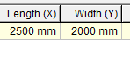
We require the following dimensions and quantities (rotated or horizontal):
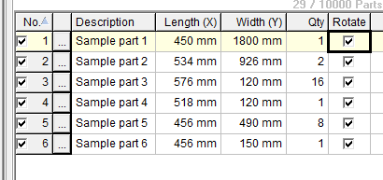
Should output: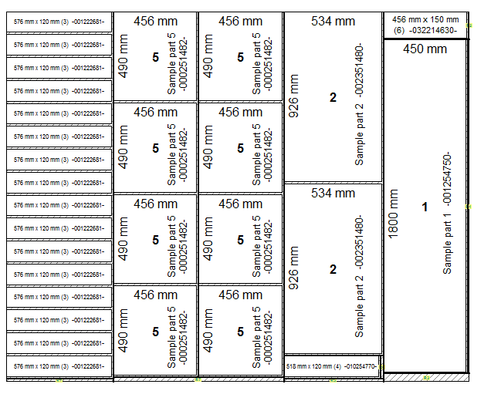
To give a total SA of 4.823 sq m utilizing 96.46% of the panel.

