This are equations, where and is known.

is constant (Known).

, are unknowns.

is just parameter.

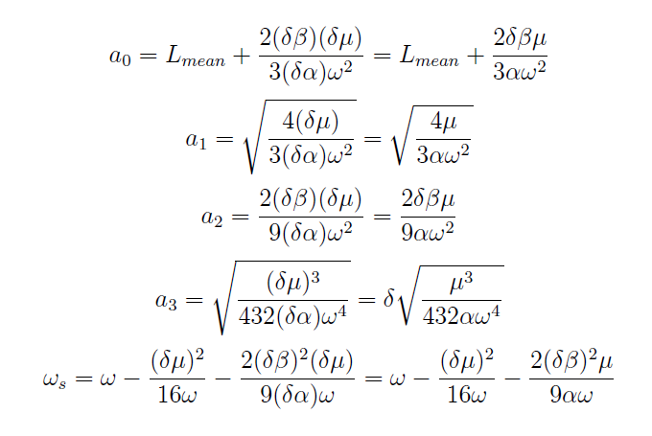

What conversion I’m looking is given below; (alpha , mu and beta are comes with delta parameter)

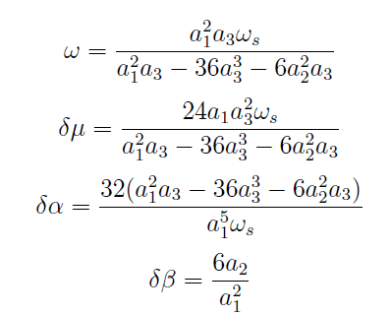

Please help me to get these unknowns as shown above (in maple), so that I can use same command or code to solve problems like this.

Thank you in advance.