|  |  |
| --- | --- |
| (4) |  |



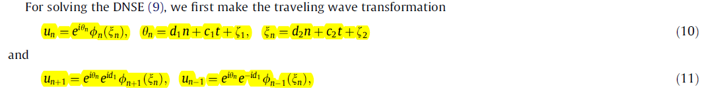

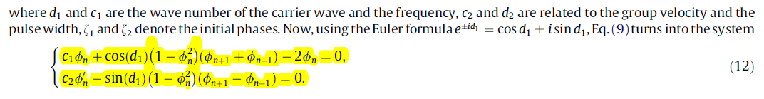



|  |  |
| --- | --- |
| (13) |  |
|  | where |
| (14) |  |



|  |  |
| --- | --- |
| **(15)** |  |
| **(16)** |  |

***#* We assume *p* = [−1*,* 1*,* 1*,* 1] and *q* =[1*,*−1*,* 1*,*−1], and so expression (14) turns to**

|  |  |
| --- | --- |
| **(17)** |  |

|  |  |
| --- | --- |
| **(18)** |  |
| **(19)** |  |

**Equations 17, 18 and 19 are placed in 15 and 16.**

**And then I think they will be simplified with the following commands:**

**simplify(eq01); fin1 := simplify(numer(%));**

**simplify(eq02); fin2 := simplify(numer(%));**

**subs(tanh(xi[n]) = Psi, fin1); fin3 := simplify(%);**

**subs(tanh(xi[n]) = Psi, fin2); fin4 := simplify(%);**

**for i from 0 to degree(fin3, Psi) do**

**EQ[i] := simplify(coeff(fin3, Psi, i));**

**end do;**