$\frac{∂^{α}u}{{∂t}^{α}}=\left(ru-rx\frac{∂u}{∂x}\right)\frac{t^{1-α}}{Γ\left(2-α\right)}-\frac{Γ\left(1+α\right)}{2}$ $σ^{2}x^{2}\frac{∂^{2}u}{{∂x}^{2}}$……………………………….1

$g\left(t\right)=c_{3}\frac{t^{α-1}}{Γ\left(α\right)}$ ……………………………………………………………………………….2

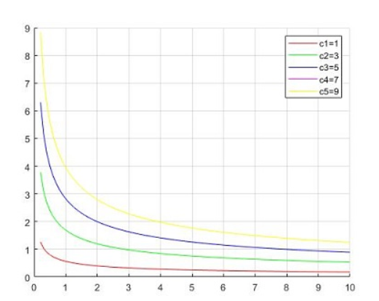…………………………………3
Equation 1 is a fractional black-scholes equation where r is the risk free interest rate,$σ=constant, α$=volitality,upon using Lie symmetry techniques, I managed to solve it and found the invariant solution which is given by (2), (3) is the graphical solution of (2). Now I need help on how I can plot equation 1 and compare and intepret obtained solution with 3. How can I do all this using maple? And how can I plot all the information in one figure? Thank you.

